2018

**WELCOME TO ISLAND CHAPEL’S**

**BARNES ISLAND SUMMER CAMP**

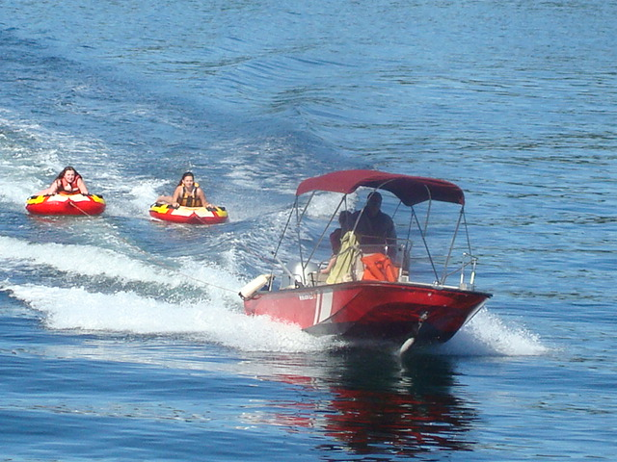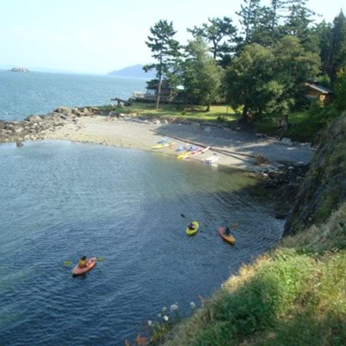*JH/HS CAMP*

*$175*

*Aug 6 – Aug 10*

*(Family Camp Reminder July 30-Aug 3)*

Barnes Island is located 10 minutes from Lummi Island between Clark and Orcas. It is rustic camping with an outdoor hot shower, 4 outhouses, and barn/tent camping. There is a house with a full kitchen for cooking (plus BBQ grill) and electricity.

**ACTIVITIES: KAYAKING, FISHING, HIKING, ISLAND HOPPING, BOATING, GAMES, GREAT FOOD AND TIME IN GOD’S WORD**

ANY QUESTIONS PLEASE CALL PASTOR

CHRIS IMMER AT (360) 296-4963

2018 Registration /Medical Consent Form

_____________________ _____________________ ______________ ______ ________________ _____

**Last Name First Name Birth date M/F Grade going into Age**

____________________________________ ___________________________________________________________________

**Address City/State/Zip**

**Phone(**________)________________**Parents (Guardians) name** __________________________________________________

**Father’s work phone** _____________________ **Mother’s work phone** ______________________________________________

**Father’s cell phone** ______________________ **Mother’s cell phone** _______________________________________________

**Parent Email:** ____________________________________________________________________________________________

**Name & Phone # of emergency contact** ________________________**Relationship**____________________________________

**Boys: Do you have a tent?** ______ **Sharing tent with:** ______________________ **Do you need a tent?** ______________

**Girls sleep in the loft of the barn: Bring Air Mattress if needed**

**Medical Consent form** – TO WHOM IT MAY CONCERN; As parent and/or guardian, I do herewith authorize treatment under the direction of any licensed physician of the following minor in the event of a medical emergency which, in the opinion of the attending physician, may endanger life, cause disfigurement, physical impairment or undue discomfort if delayed. This authority is granted only after a reasonable effort has been made to reach me by phone at the number listed below.

**Name of Minor** _________________________________________

**Dates permission is effective** __________________________**Parent’s phone #** (_______)______________________________

**Family Physician** ________________________________ **Physician’s phone #** (_______)_______________________________

**Family Medical Insurance and member number** ________________________________________________________________

**Specific medical allergies, chronic illnesses, or other condition** __________________________________________________

_________________________________________________________________________________________________________

**Medications now being used** ________________________________________________________________________________

**Any restrictions on camp activities?** ______________________________**Date of last tetanus shot?** _________________

I do herewith authorize the acting camp dean to dispense non-prescription medication per manufacturer’s recommendations for minor

incidents of sunburn, headaches, etc.**.** Please circle all that apply and sign.

*Acetaminophen Ibuprofen Antihistamine Topical lotions/* sunscreen

**Parent or Guardian Signature:** ____________________________________________ Date__________________________

Camper Prescription medications need to be given to the Dean upon arrival and are the responsibility of the camper to self-administer.

_ _ _ _ _ _ _ _ _ _ _ _ _ _ _ _ _ _ _ _ _ _ _ _ _ _ _ _ _ _ _ _ _ _ _ _ _ _ _ _ _ _ _ _ _ _ _ _ _ _ _ _ _ _ _ _ _ _ _ _ _ _ _ _ _ _ _ _ _ _ _

Please bring (and label): Bible Toothbrush/paste Sleeping Bag Air mattress (if needed)

Swim Suit** Bug Spray Sunscreen/hat Light Jacket for evening

Pants/shirts Sweatshirt Shoes for games Flip Flops for shower

Deodorant Shampoo Sunglasses Tent with rain guard or tarp (boys)

Flashlight 2 Towels Water shoes Water Bottle

\*\**\*No Bikinis or low cut shirts, bring an extra tank top to cover swim suit*

PARENT CONSENT FORM

I approve the participation of my minor child in Island Chapel’s summer camp and waive any and all claims against the same, its board or representatives due to injury or other damages incurred to the camper or said campers property in connection with the summer camping program.  I assure that my child is in good physical health and able to attend camp.  I understand that my camper’s participation in summer camp activity may expose him/her to physical and challenging situations.  I understand that although the camp has taken precautions to provide proper organization, supervisions instruction and equipment it is not possible to guarantee absolute safety. Camper and parent/ guardian understand that they share responsibility for their campers’ safety and they accept that responsibility.

I give Island Chapel permission to use my child’s photo for publicity purposes.

I authorize camp staff to release my child to the following individuals:

_____________________________________ ___________________________________

Parent: ______________________________ Date: ______________________________

CAMPER AGREEMENT

I agree to follow camper expectations as outlined by the Dean, respect myself and others and the campgrounds. I will follow the schedule, use proper language that is not abusive to staff or fellow campers or is profane. I will take proper care of all camp equipment and property. I will dress appropriately and make an effort to be helpful.

In case of dismissal due to voluntary withdrawal or disciplinary actions there will be no refund of camp fees.  I fully understand that failure to abide by camp policy may lead to my being sent home.

Camper: _______________________________________ Date: ______________________________